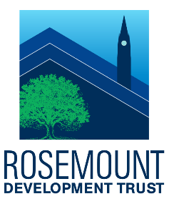
Rosemount Development Trust
Community Benefit Fund Application Form

Date

Name of Organisation
Address
Post Code
Organisation Website

Contact Person
Position Within Organisation
Telephone Number
Email Address

Have you received funding from RDT before? | Yes/No

Please provide a brief description of your organisation and the activities you deliver

Please describe the project or activity you are seeking funding for

Which option best describes the project or activity you are applying for?
(Check any applicable boxes)
To benefit residents of Royston | ☐
To benefit areas neighbouring Royston | ☐
Please specify any areas out with Royston which will benefit
To relieve unemployment | ☐
To advance citizenship and community development | ☐
To relieve those in need by reason of age (young or old) | ☐
To relieve those experiencing ill-health | ☐
To assist those affected by disability | ☐
To assist those facing financial hardship | ☐

Please provide indicative dates for when the project or activity will start and end

What is the total cost of this project or activity
How much funding are you requesting from Rosemount Development Trust

Any other relevant information (optional)

Declaration:
By submitting this form I confirm that:
- To the best of my knowledge, all information included is correct
- I am authorised to apply to the Rosemount Development Trust Community Benefit Fund on Behalf of my organisation

Signed:

Date:

